An Evaluation of Computational Fluid Dynamics for Spillway Modeling
Group Members’ Names
Couse Title
Professor’s Name
Date of Submission

Introduction
Background Information
In the past, many techniques of modelling have developed quickly as the CFD power has been enhanced to where many solutions are possible for broad applications. This has headed to the use of modelling as a conventional design tool in many engineering fields. Regardless of many modelling applications, all the models are same in a base of fundamental principles of the models. CFD is a division of arithmetical modelling that is advanced for cracking problems concerning fluid flow. This may involve fluid-solid interaction for example water flowing in a river or over hydraulic structures. This has brought about an exciting part of hydraulic for the engineers to apply a CFD to perfect fluid flow at the hydro-electric generating station. CFD provides a three-dimensional flow field around curved objects and other details on a stream that is not found in two-dimensional models although it takes a lot of time to compute. This project emphases on how to use CFD to perfect the flow of water through the spillway.
In history, investigations have been carried out on water flow over spillways using model experiments. The researchers have shown that laws were used to convert the model flow information in to a scale value. The physical modelling method of investigating the performance of spillway was successful before, but the CFD has many advantages over it. CFD will only require on skilled personnel to operate the program and explore different options and can allow the user to acquire flow information at any point. On the other hand, physical modelling is very expensive concerning construction and hiring it requires many qualified engineers and it cannot explore a variety of options. Therefore the advantages of CFD has made engineers to create interest in the field of hydraulic in verification of full capability of arithmetical models. This project is built to assess the capacity of CFD to perfect the nearby spillways.
Objectives of the study
As explained in the above, engineers in a hydraulic field have been interested in CFD and therefore have turned to its use to model fluid flow in the hydroelectric power generation concerning flow over the spillway. Thus the engineers have been working hard to use the CFD to evaluate the performance with comparison to physical modelling over water flow spillway. Exploring these advantages and verifying Flow-3D against physical models will be the focus of this research. In particular, the objectives of this research include: To come up with a physical model and install it in hydroelectric power generator in the nearby station so that we may conduct it directly to flow 3D comparison desired flow data.
- To model flow-rate over a spillway with different headwater levels for comparison to physical model data, the upstream boundary was set as a specified fluid height.
- To give summarized research on a spillway CFD modelling flows from existing investigations.
- To gather data from previously completed models on spillways and compare it with values obtained using CFD software Flow-3D.
Literature Review
Many studies have shown that, CFD has been applied to spillway modelling and the results could agree with those obtained from the physical model. According to Sartaj et al (2006), comparison have been carried out and found that the CFD flow-3D software was more reliable than the physical model. Much of the studies only expresses how this program uses limited alteration solution system and the fluid amount method. Flow -3D use a method that relies on the fraction of the area or volume to define the obstacle. In another study where the Flow-3D model was used to calculate discharge and pressure on crest gave results that agreed with the physical model study, (Choi et al, 2015).
Methods
Mesh convergence study
With relevance to CFD arithmetical model, a mesh is a portion of the flow area in moderately minor regions known as cells in which arithmetic values like pressure, are calculated. The most sensitive part of the arithmetical model simulation is defining the appropriated mesh domain along with the best mesh size of a cell. The mesh and the cell size influence the accuracy of the results. The best way to define the mesh size is to start with a large mesh and reduce it until the desired output is given. This will allow the user of the Flow-3D to run the simulation and make as many changes as possible. In my project, I modelled spillways that had a uniform mesh and a cell size of 1M.
To start with restart runs were then completed using the mesh that was uniform and 0.5 M. The mesh for flee overflow was set at dress 0.25 M – a simulation where the discharge was the desired model output. A similar process was also used when looking at free overflow water surface pressure data. 0.4 m and 0.33 m meshes were also utilized in an attempt to reduce simulation times. During conduction of gated simulations, the process was modified to give the results using 1M, 0.25 M and 0.5M although the results did not correspond to physical model data. Use of nested mesh blocks improved the resolution without excessive increase in the cell number. Finally, the simulations were run using two nested mesh blocks in the area.
Boundary and initial conditions
In this study, the top boundary was set as the atmospheric pressure while the bottom limit was established as a wall. The bottom boundary was set just below the model geometry, and the top boundary was placed above the highest level of water. This two ensured that there was the extension of mesh in vertical or z-direction. The downstream boundary was set at the height of the fluid. This was done because the study aimed to model the rate overflow over a spillway with different headwater levels and compare this with data obtained from physical model-this was an extension of x-direction. The boundary condition in the y-direction or the perpendicular is contingent on the amount of modelled spillway.
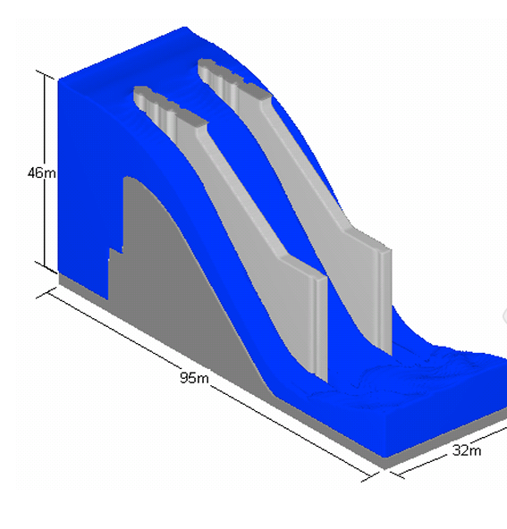Arithmetical model

The model for the nearby station was set after obtaining the previous result of the physical model. The results were used to prepare an Auto-Cad drawing and imported into Flow-3D for the remainder of the arithmetic model set up. The initial simulations were run and finished without including upstream boundary. The following data were obtained and compared with physical model data.
Results and Discussions
Data
Results of mesh convergence study and computational time of the CFD simulations
Head  (M) | The physical model (M3/S) | CFD- without upstream | Percentage difference | CFD-with upstream | Percentage difference
3.5 | 230 | 266 | 15.0 | 258 | 10.0
5.5 | 475 | 535 | 12.1 | 510 | 7.0
7.5 | 800 | 894 | 11.5 | 855 | 6.8
9.5 | 1150 | 1270 | 10.0 | 1210 | 5.0
11.5 | 1600 | 1757 | 9.7 | 1667 | 4.1
12.7 | 1905 | 2090 | 9.7 | 92 | 4.1
14.2 | 2250 | 2488 | 10.6 | 2335 | 3.8

From these results of mesh convergence, using similar mesh sizes, it is clear that the arithmetic model required less time to generated quality results compared to the physical model which required more personnel and time consuming in order to generate results. The computational time for the CFD simulations is less for the arithmetic model while the physical model requires more time to compute the results through the discharge.
Overflow simulations
Simulations were completed with the primary aim of cross-checking discharges in the free overflow, the surface of the water and the surface pressure in contradiction of the physical model. The initial simulations were completed using the Flow-3D restart option with the mesh size of 0.5M to enhance accuracy. A rating curve was drawn as shown below as it was compared to the physical model rating curve.

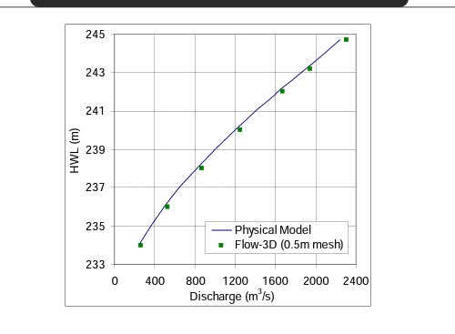
From the curve, it is well demonstrated that discharges of Flow-3D are larger than that of physical model flows.
The next simulations were conducted with the aim of regenerating profile of the surface of the water along a spillway. In the physical model, the Centre-line of 14.2 M for the water head was available and was explicitly set for comparison. In this case, the initial mesh of 0.5 M was used and generated the excellent contrast. The 0.25M restart simulation gave a better comparison.
The different comparison was carried out between the arithmetical model and physical model which involved the rollway of the Centre-line with the upstream set 11.5 M above the water level. Although the initial comparison was made using a mesh of 0.5 M, the 0.25M mesh gave the best comparison. This was summarized as shown in the figure.
Multiple of Headwater density | Head (M) | Physical model M3/S | 1M mesh  CFD (M3/S) | 1M mesh  %diff | 0.5M mesh  CFD M3/S | 0.5 M mesh  %diff
0.12 | 1.8 | 725 | 564 | -21.9 | 545 | -24.4
0.27 | 3.8 | 1600 | 1732 | -7.8 | 1434 | -9.9
0.39 | 3.8 | 2890 | 2817 | -2.5 | 2783 | -3.7
0.51 | 5.8 | 4380 | 4325 | -1.2 | 4248 | -2.9
0.68 | 7.8 | 6340 | 6214 | -2 | 6177 | -3.7
0.80 | 9.8 | 8140 | 8163 | 0.3 | 8030 | -1.3
0.94 | 11.8 | 10100 | 10153 | 0.5 | 8969 | -1.2
1.02 | 13.8 | 11050 | 11248 | 1.7 | 11059 | 0.1
1.08 | 15.8 | 11995 | 12219 | 1.8 | 12032 | 0.3

These results did compare with the results that were obtained from related researchers mentioned in the literature review. From the similar study, it was shown that CFD over-estimated the physical model flow-rates. It also showed that the there was a reduction in discharge when the size of a mesh was reduced. Furthermore, the mesh refining led to the more significant difference in the two types of modelling in the station.
The significance of this results to my parametric study is that, one is able to draw a noticeable difference in terms of efficient in working with the CFD flow-3D model than operating the manual physical model which takes a lot of time and requires a trained personnel to give out the results. Concerning the parameters of the pressure as used in this study, it is clear that it is efficiently to determine it using the CFD model than physical model.
Concerning the accuracy of the results obtained, I may commend that the CFD model outcomes were highly accurate since these were machine done work. This is so because, once the machine is set no interferences from personnel, that is, it is let to work independently. On the other hand, some errors were suspected in the outcomes of physical model which may have come from personnel related adjustments.
In real world, these results are very important in that, they help in choice of the most preferable method for spillway simulations in power generating stations. Similarly, due to rapid growth in technology has led to adoption of high technological methods to substitute the traditional methods which are time consuming.

Conclusion
To sum up, it is clear that the performance of the CFD Flow-3D was verified to be very okay. It gives more reliable outcomes than the physical model; it is able giving accurate spillway discharges. It was also clear that the Flow-3D can model the water surface spillway for different headwater levels using different gate openings compared to the physical model. Lastly, depending on the required data, a mesh can be refined to 0.5M in size for better results. Nested mesh improves the Flow-3D discharges giving quality results than those of physical model.
Recommendations
- I would like to recommend the government to absorb this project to help in the development of an excellent model which is the CFD Flow-3D model to perform arithmetical modelling. This will help to replicate patterns pressure and velocity in the hydroelectric stations.

- Technology has been rapidly growing, therefore I would also like to encourage engineers to come up with similar models which uses a software so as to speed up the rate of operations, in most of the upcoming companies.

References

Director, I. N. E. T. HTR-PM of 2014: toward success of the world first Modular High Temperature Gas-cooled Reactor demonstration plant.
Sartaj, M., Beirami, M., Fooladgar, A. 2006. Analysis of Two-Dimensional Flow over
Standard Ogee Spillway Using RNG Turbulence Model. 7th International Congress on
Civil Engineering.
Choi, W., Jeon, J., Park, J., Lee, J., & Yoon, S. (2015). System reliability analysis of downstream spillways based on collapse of upstream spillways. International Journal of Agricultural and Biological Engineering, 8(4), 140.

